DR YSR GVOT DEGREE COLLEGE, VEDURUKUPPAM
National Service Scheme – Unit-1
Swarnandhra Swatchandhra
-----------------------------------------------------------------------------------------------------------------
Theme of March– 2025 : source segregation and zero waste life cycle
No of NSS Volunteers participated : 65
No of Teaching and Non-teaching Staff participated :17
Agenda of the Programme:
- Inauguration of Programme
- Awareness programme of the surrounding’s cleaning and zero waste cycling
- Oath of Swarnandhra Swatchandhra
The National Service Scheme (NSS) Unit of [Your Institution Name] organized an awareness and action program on “Source Segregation and Zero Waste Life Cycle.” The initiative aimed to educate students and the community about proper waste management practices and the importance of reducing waste generation.
Objectives:
- To promote segregation of waste at the source
- To create awareness about the zero-waste concept
- To encourage recycling and reuse of materials
- To reduce environmental pollution and landfill waste
Program Details:
The program began with an introductory session by the NSS Program Officer, explaining the importance of segregating waste into biodegradable and non-biodegradable categories. Volunteers were guided on how proper segregation at the source can make recycling and disposal more effective.
NSS volunteers actively participated in a demonstration of waste segregation using color-coded bins. A cleanliness drive was conducted where waste was collected and sorted accordingly. Awareness campaigns were carried out to educate people about composting organic waste and reducing the use of plastic.
The concept of a zero-waste life cycle was explained, emphasizing practices such as reducing consumption, reusing materials, recycling waste, and composting organic matter.
Activities Conducted:
- Demonstration of source segregation
- Waste collection and sorting activity
- Awareness campaign on zero-waste practices
- Promotion of composting and recycling
- Interaction with community members
Outcome:
The program successfully created awareness about responsible waste management and the benefits of a zero-waste lifestyle. Participants developed a better understanding of how small changes in daily habits can reduce waste and protect the environment.
Conclusion:
The activity on source segregation and zero waste life cycle was informative and impactful. It encouraged students and the community to adopt sustainable practices and contribute towards a cleaner and healthier environment.
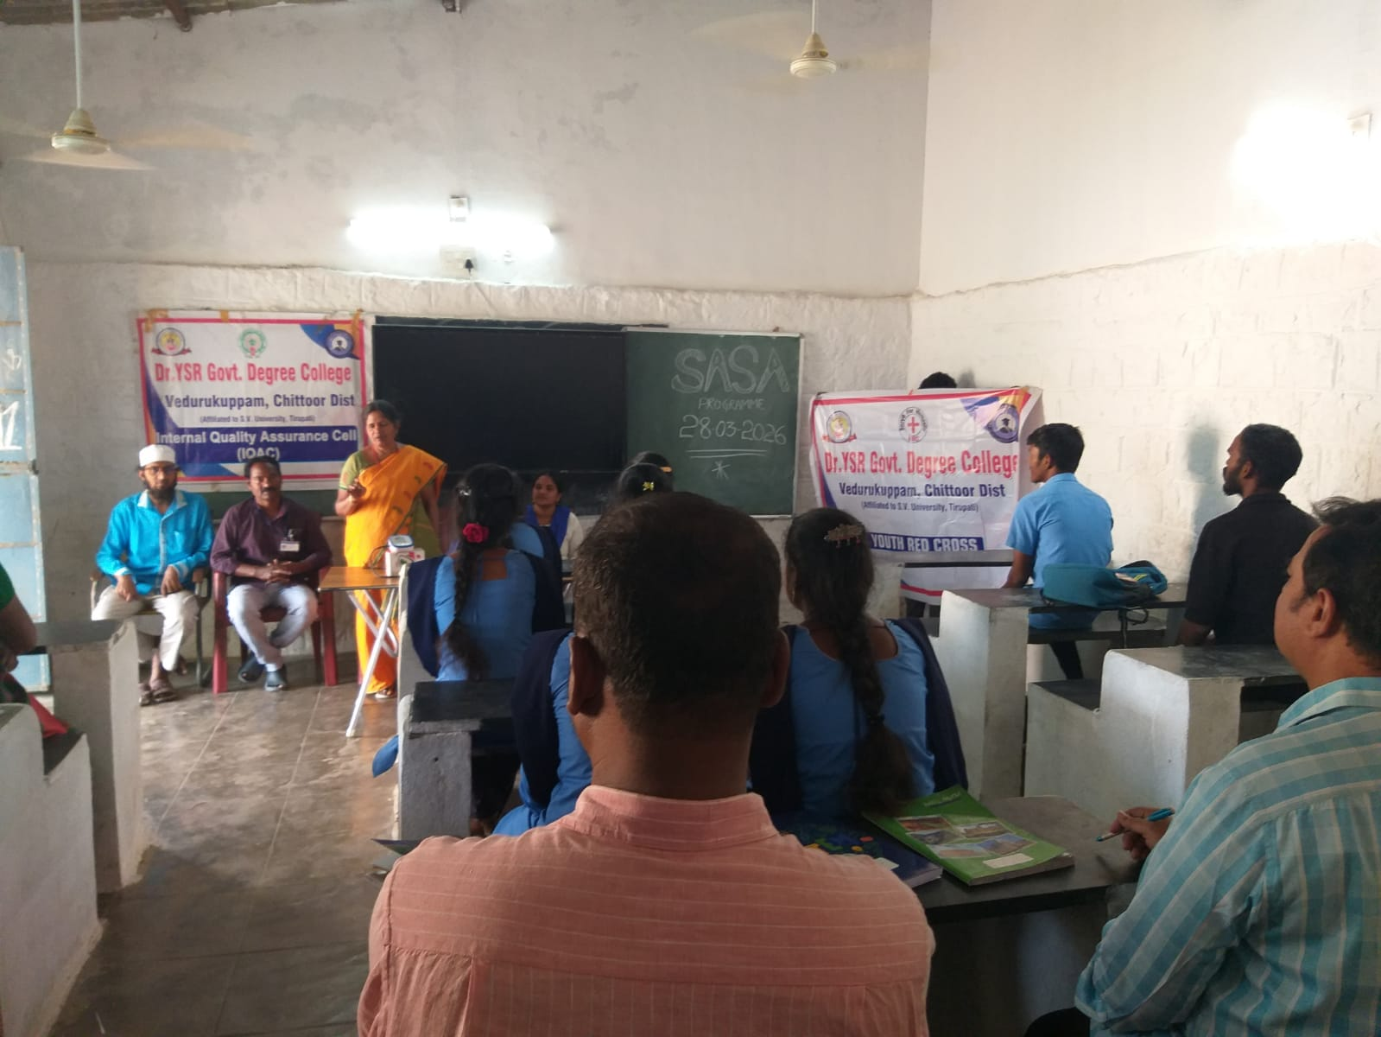
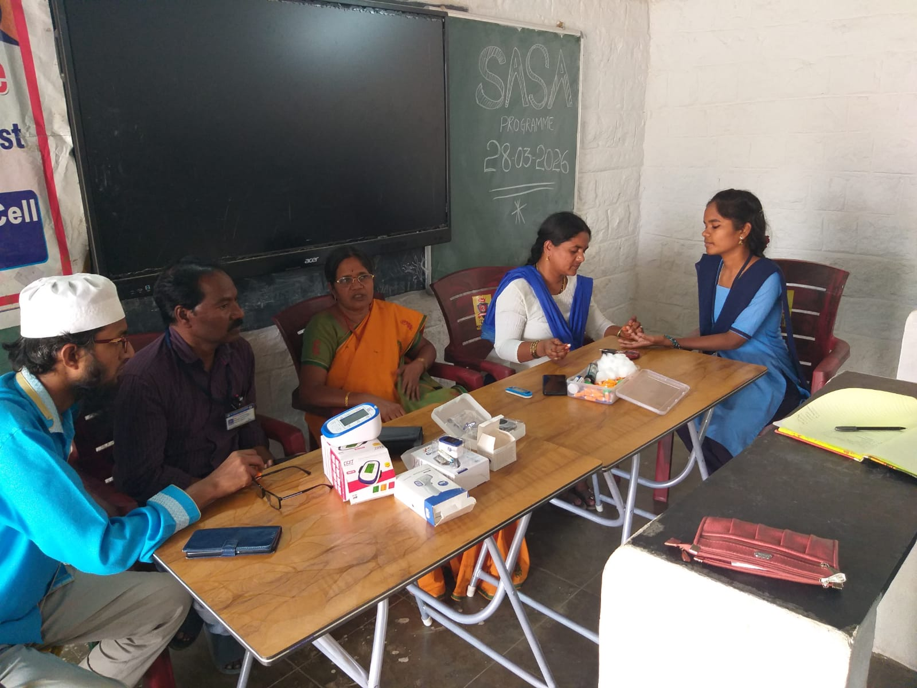
Program: testing the blood groups as per instruction of the govt.
